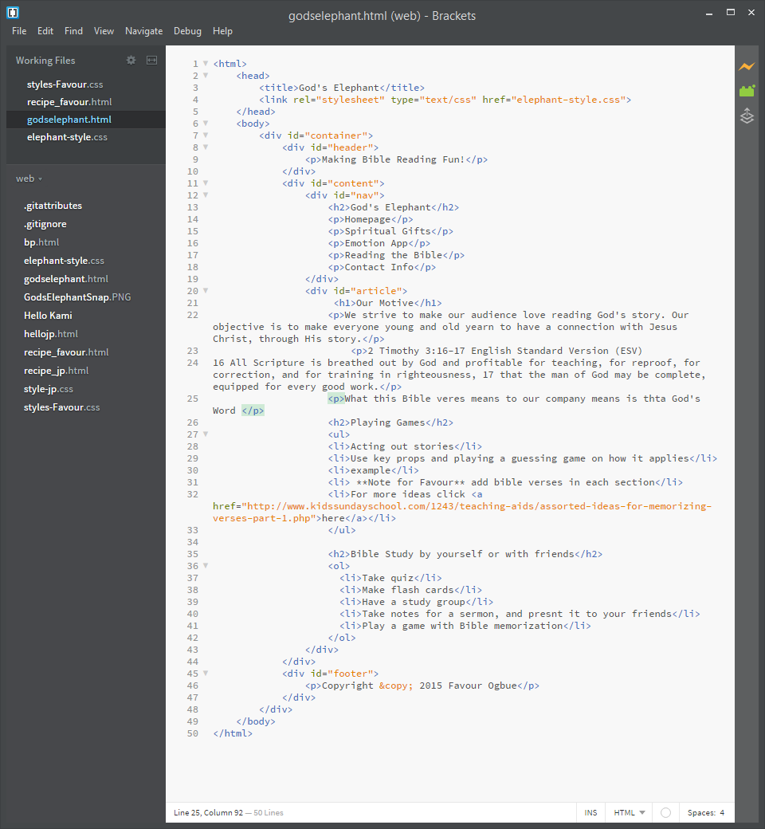Yes all my code is indented and organized, but there are a few spelling errors. Yet all elements open and close in the same place, and the proper syntax is used

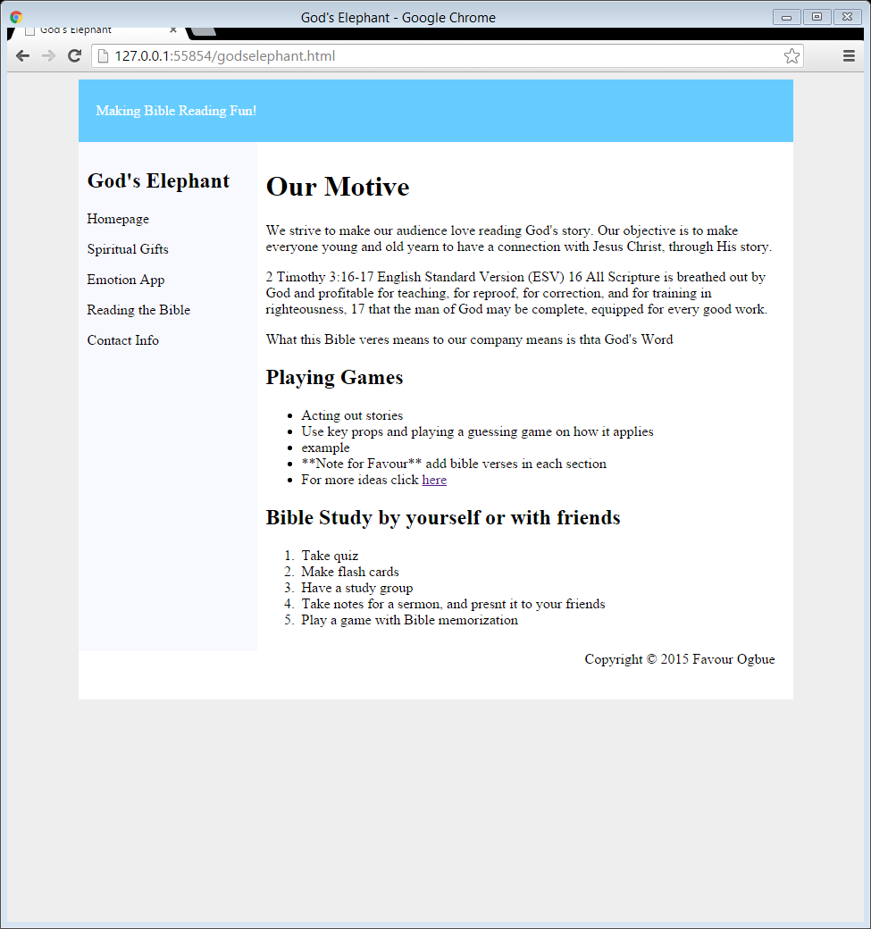

I think that for the evaluation, my webpage gets a 6 out of 10. The layout and information and the biggest obstacles for my final product. The problems are not knowing how to get the website the way I see it in my mind. I have questions like what the color scheme would be, how to make it more appealing to our audience, how to add images without making it overwhelming. I can look online for examples, ask my friends who are working on the website with me, or ask the teacher. I need to know how to reach the readers, and how to code well